IACE “Fun Walk 2019”

We are pleased to announce that IACE “Fun Walk 2019” will be held in April 2019. Parents and friends of all Corps members are also cordially invited to the event. Their support in terms of donation and participation are always welcome. Details of the activity are as follow:

Date: | 28 April 2019 (Sunday)
Time: | 1000 hrs to 1330 hrs
Roll Call Location: | Quarry Bay Park Phase 1 (i.e. near Cityplaza Four)
Dress Code: | Corps Members: Squadron Tee / Wing Tee / Corps Tee, Sports Trousers, Sports Shoes  Non-Corps members: Sports Casual
Route: | Quarry Bay Park Phase 1→ Quarry Bay Promenade → Fireboat Alexander Grantham Exhibition Gallery → Quarry Bay Park (i.e near Lei King Wan)  (Please refer to Map of Route for details)
Coach Service: | A coach will be arranged for picking up participants at Tsuen Wan MTR Station to Quarry Bay.  Please reserve the seats by filling in the enclosed reply form by 15 April 2019 (Mon), First-come-first-served.
Minimum Donation: | $200 for each squadron,  $700 for applicants of IACE 2019 Outbound Operation
Collection of Donation Forms: | Kindly nominate a unit representative for collection of donations forms. Please keep the forms in good condition upon collection from our committee. Our staff will collect the forms on the day of the event for calculation of Fund raised.

We have also prepared a series of exciting games for all participants during the “Fun walk”. Prize will be awarded to the following:
- The Highest Amount Fund-raising Cadet,
- The Highest Turnout Squadron; &
- The Ultimate Winning Team of mini-games.

Kindly submit the reply form by email no later than 15 April 2019 (Mon) to hkaccocieu@gmail.com & inbound.iace@gmail.com. Should you need further information, please feel free to contact us by email.

We look forward to seeing you on that day.

Toby Y P NG
Squadron Leader
Officer Commanding International Exchange Unit

Encl. Map of Route for “Fun Walk” & Reply Form
Return Point

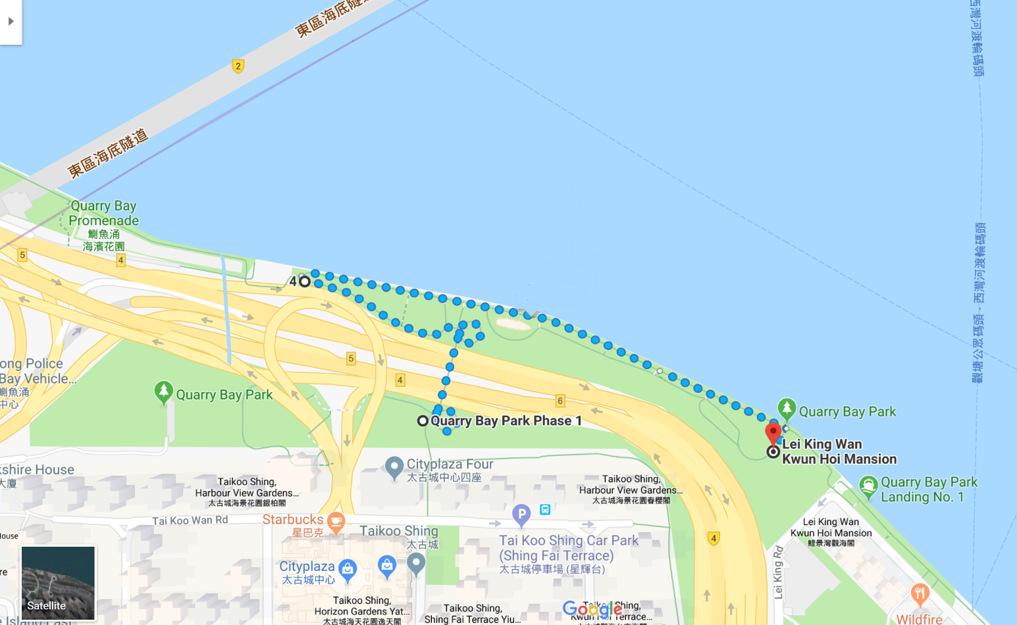

Fireboat Alexander Grantham
End Point

Start Point

